

Darshan University

A Project Report on

**“Online Shopping System”**

Under the subject

**Software Engineering (2301CS405)**

B. Tech, Semester – IV

Computer Science & Engineering Department

|  |  |
| --- | --- |
| Submitted By | |
| Student Name: Aayushi Sata | Enrollment No.: 23010101245 |
| Academic Year  (2024-2025) | |
| Internal Guide  Prof. R. B. Gondaliya  Darshan University | Dean-DIET  Dr. Gopi Sanghani  Darshan University |

|  |  |
| --- | --- |
|  | **Computer Science & Engineering Department**  **Darshan University** |

**DECLARATION**

We hereby declare that the SRS, submitted along with the **Software Engineering** **(2301CS405)** for entitled **“Online Shopping System”** submitted in partial fulfilment for the Semester-4 of **Bachelor Technology (B. Tech)** in **Computer Science and Engineering (CSE)** Departmentto Darshan University, Rajkot, is a record of the work carried out at **Darshan University, Rajkot** under the supervision of R. B. Gondaliya and that no part of any of report has been directly copied from any students’ reports, without providing due reference.

Aayushi Sata

Student’s Signature

Date: __________

|  |  |
| --- | --- |
|  | **Computer Science & Engineering Department**  **Darshan University** |

**CERTIFICATE**

This is to certify that the SRS on **“Online Shopping System” has** been satisfactorily prepared by **Aayushi Sata** (**23010101245**) under my guidance in the fulfillment of the course **Software Engineering (2301CS405)** work during the academic year 2024-2025.

|  |  |  |
| --- | --- | --- |
| Internal Guide  Prof. R. B. Gondaliya  Darshan University |  | Dean-DIET  Dr. Gopi Sanghani  Darshan University |

**Acknowledgement**

I wish to express my sincere gratitude to my project guide Prof. R. B. Gondaliyaand all the faculty members for helping me through my project by giving me the necessary suggestions and advices along with their valuable co- ordination in completing this work.

I also thank my parents, friends and all the members of the family for their precious support and encouragement which they had provided in completion of my work. In addition to that, I would also like to mention the Darshan University personals who gave me the permission to use and experience the valuable resources required for the project from the University premises.

Thus, in conclusion to the above said, I once again thank the faculties and members of **Darshan University** for their valuable support in completion of the project.

Thanking You

**Aayushi Sata**

**ABSTRACT**

An online shopping Management system is a computerized platform that facilitates customers to browse and purchase products online. This system transforms the traditional shopping experience into a digital one. The project comes with several features that are typically not available in traditional shopping systems, such as user login, easy product search, and instant order placement. Additionally, it has an admin login feature, which allows the admin to oversee the entire system.

The system is equipped with basic functionalities like allowing the admin to add, view, update, and delete products and customer information. Customers, after logging into their accounts, can view the list of products, their prices, and availability. They can also track their orders, view order history, and place requests for out-of-stock items using a request form. The admin, upon logging into their account, can generate various reports such as customer reports, order reports, product reports, and sales reports.

Main purpose of this system is to reduce human efforts as much as possible.

**Table of Contents**

List of Figures I

List of Tables II

1 Introduction 1

1.1 Product perspective 1

1.2 Product features 1

1.2.1 There are three different users who will be using this product: 1

1.2.2 The features that are required for the Librarian are: 1

1.2.3 The features that are required for the Member are: 1

1.3 Functional Requirement 1

1.3.1 Librarian 1

1.3.2 Member 2

1.4 Non-Functional Requirement 2

1.4.1 Usability: 2

1.4.2 Accuracy: 2

1.4.3 Availability: 2

1.4.4 Maintainability: 2

2 Design and Implementation Constraints 3

2.1 Use case diagram 3

2.2 Activity diagram and Swimlane diagram 4

2.3 Sequence diagram 5

2.4 State diagram 6

2.5 Class diagram 7

2.6 Data flow diagram 8

2.6.1 Context diagram (level-0) 8

2.6.2 DFD Level-1 8

2.6.3 DFD Level-2 9

3 External interface requirement (Screens) 10

3.1 Screen-1: Registration Form 10

3.2 Screen-2: Login Form 11

3.3 Screen-3: Add borrower book 12

4 Database design 13

4.1 List of Tables 13

5 Stories and Scenario 14

5.1 Story-1: Add New Book in Library Catalogue 14

5.1.1 Scenario# S1.1 14

5.1.2 Scenario# S1.2 14

5.1.3 Scenario# S1.3 14

5.2 Story-2: Search Book 15

5.3 Story-3: Manage due date for borrowed book 15

5.4 Story-4: Renew book 15

5.5 Story-5: Generate a report on book usage and availability 15

6 Test cases 16

7 References 20

# List of Figures

Figure 2.1‑1 Use case diagram for library management system 3

Figure 2.2‑1 Activity diagram for Book Issue 4

Figure 2.2‑2 Swimlane diagram for Book Issue 4

Figure 2.3‑1 Sequence diagram for Book Issue 5

Figure 2.4‑1 State diagram of Book 6

Figure 2.4‑2 State diagram for Librarian 6

Figure 2.5‑1 Class diagram for Library management system 7

Figure 2.6‑1 Context diagram for Library management system 8

Figure 2.6‑2 DFD level-1 for Library management system 8

Figure 2.6‑3 DFD level-2 for Issue book 9

Figure 3.1‑1 Screen-1: Registration Form 10

Figure 3.2‑1 Screen-2: Login Form 11

Figure 3.3‑1 Screen-3: Add borrower book 12

# List of Tables

Table 3.1‑1 Screen element of Registration form 10

Table 3.2‑1 Screen element of Login form 11

Table 3.3‑1 Screen element of Add borrower book 12

Table 4.1‑1 Table: Book 13

Table 4.1‑2 Table: Borrower 13

Table 4.1‑3 Table: Staff 13

Table 4.1‑4 Table: Student 13

# Introduction

## Product perspective

This project aims to transform the manual shopping system into an internet-based application, enabling users to manage their accounts, check product availability, and make purchases online. It is a multi-user platform that handles all fundamental functions of an online store, such as product cataloguing, order processing, inventory management, and customer service. This system efficiently supports the essential operations of an online shopping platform, catering to the needs of both small and large-scale e-commerce businesses.

## Product features

### There are three different users who will be using this product:

* **Admin**: Website owner who manages and oversees the entire system.
* **Seller**: A user who sells product or service on the platform.
* **Customer**: A registered user who can browse, purchase products, and manage their account.

### The features that are required for the Admin are:

* Control the platform operations to ensure smooth functionality.
* Can view all user accounts, including customers, sellers, and guests.
* Monitor and approve product listings by sellers.
* Can generate reports such as sales, inventory, and user activity reports.
* Can search for specific products or users using various criteria.
* View, edit and insert new product categories.
* Update platform content, including FAQs and policies.
* Monitor customer support activities.
* Access and edit platform settings and configurations.
* Review and respond to feedback from customers and sellers.

### The features that are required for the Seller are:

* List new products for sale on the platform.
* Set and Update pricing for products
* Update existing product listings.
* Can view and process customer orders.
* Can handle customer inquiries and provide support.
* Receive notifications about orders, inquiries, and returns.
* Can access, generate sales reports and performance analytics.
* Offer discounts and promotional deals on their products.
* Access and update their account information.
* Monitor sales performance and track revenue.

### The features that are required for the Customer are:

* Can log in and manage their profile information.
* Browse products by categories, brands, and other filters.
* Search for specific products using keywords.
* View detailed product descriptions, images, and reviews.
* Add products to the shopping cart.
* Proceed to checkout and place orders.
* Track the status of their orders.
* Provide reviews and ratings for purchased products.

## Functional Requirement

### Admin

* Login: Admin can securely log in to access the admin account.
* View User: Admin can view a list of all users registered on the platform along with their details.
* Remove User Account: Admin can delete user accounts from the platform as needed, ensuring proper data management and user privacy compliance.
* Manage ads: Admin can manage the type of advertisements customers have to see according to seller’s sponsorship.
* View Seller: Admin can view a list of all sellers registered on the platform along with all their details.
* Remove Seller: Admin can delete trader’s account if found seller breaking rules and for security purposes.
* **Customer Support:** Admin can oversee customer support operations and respond to inquiries or issues.
* Receive **Reviews and Ratings:** Admin can receive customer reviews and ratings.
* Reply to Reviews: Admin can reply to customer’s reviews and ratings.
* **Platform Customization:** Admin can customize the platform's theme, layout, and branding.

### Customer

* **Login**: Customers can securely log in to their account to access personalized features.
* **Registration: Customer can register him/herself.**
* **Search Products:** Customers can search for products using keywords.
* **Apply Filters:** Customers can apply filters (e.g., price range, brand, size) to refine search results.
* **Select Category**: Customers can browse and select products by category.
* **View Product Details:** Customers can view detailed information about each product.
* **Read Reviews/Ratings:** Customers can read reviews and ratings from other buyers.
* **Write Review/Rating:** Customers can write and submit reviews or ratings for products they have purchased.
* **Add to Cart:** Customers can add selected products to their shopping cart.
* **View Cart:** Customers can view the items currently in their shopping cart.
* **Select Payment Method:** Customers can choose from available payment methods (e.g., credit card, PayPal).
* **Provide Shipping Details**: Customers can enter shipping information such as address and preferred delivery date and gift wrap option.
* **Apply Coupon Code for Discount**: Customers can apply a coupon code during checkout to receive discounts.
* **Place Order:** Customers can confirm and place their order.
* **View Order Detail**: Customers can view details of their current and past orders.
* **Track Order:** Customers can track the status and location of their order in real-time.
* **Cancel Order:** Customers can cancel an order before it is shipped or delivered.
* **Return Product:** Customers can initiate a return request for products within the return period.
* **Customer Support:** Customers can contact customer support for assistance with orders, returns, or inquiries.
* **View Account Information:** Customers can access and update their account information, including personal details, communication preferences, and saved addresses.
* **Sort and Compare Products**: Customers can sort search results by relevance, price, popularity, or other criteria, and compare product specifications side by side.
* **Access Multi-language Support:** Customers can access the platform in their preferred language or choose from available language options for browsing and purchasing products.
* **Register complain at customer support:** If found any difficulty in receiving product , they can always use customer support to register their complain.

### Seller

* **Login:** Sellers can securely log in to their accounts.
* **Registration**: Sellers can register and create a new account on the platform.
* **Add Product:** Sellers can add new products to the inventory.
* **Remove Product**: Sellers can remove products from the inventory.
* **Update Product Information**: Sellers can update details of existing products.
* **Track Sales Information:** Sellers can view and track sales data and performance.
* **Provide Order Tracking Information:** Sellers can update customers with order tracking details.
* **Keep Track of Product Inventory:** Sellers can monitor and update product stock levels.
* **Provide Refund:** Sellers can process refunds for returned products.
* **View Orders:** Sellers can view all orders placed for their products.
* **Manage Shipping Details**: Sellers can manage shipping options and delivery methods for their products.
* **Respond to Customer Inquiries**: Sellers can communicate with customers regarding product inquiries and order issues.
* **Generate Sales Reports:** Sellers can generate detailed sales reports for performance analysis.
* **View Customer Feedback:** Sellers can view and respond to customer reviews and ratings.
* **Adds discounts**: Can add special discounts on their product if they want to.
* **Manage Store Profile**: Sellers can update their store information and profile details.
* **Sponsor themselves**: Sellers can sponsor themselves if they want to by paying certain amount to software and can request admin to advertise themselves.

## Non-Functional Requirement

### Usability:

* The UI should be simple enough for everyone to understand and get the relevant information without any special training. Different languages can be provided based on the requirements.

### Accuracy:

* The data stored about the books and the fines calculated should be correct, consistent, and reliable.

### Availability:

* The System should be available for the duration when the library operates and must be recovered within an hour or less if it fails. The system should respond to the requests within two seconds or less.

### Maintainability:

* The software should be easily maintainable and adding new features and making changes to the software must be as simple as possible. In addition to this, the software must also be portable.

### Security:

* The system must implement secure payment processing using encryption (e.g., SSL/TLS) and be compliant with PCI DSS standards. User data, including passwords and payment information, must be stored securely and follow GDPR or applicable data protection regulations.

# Design and Implementation Constraints

## Use case diagram

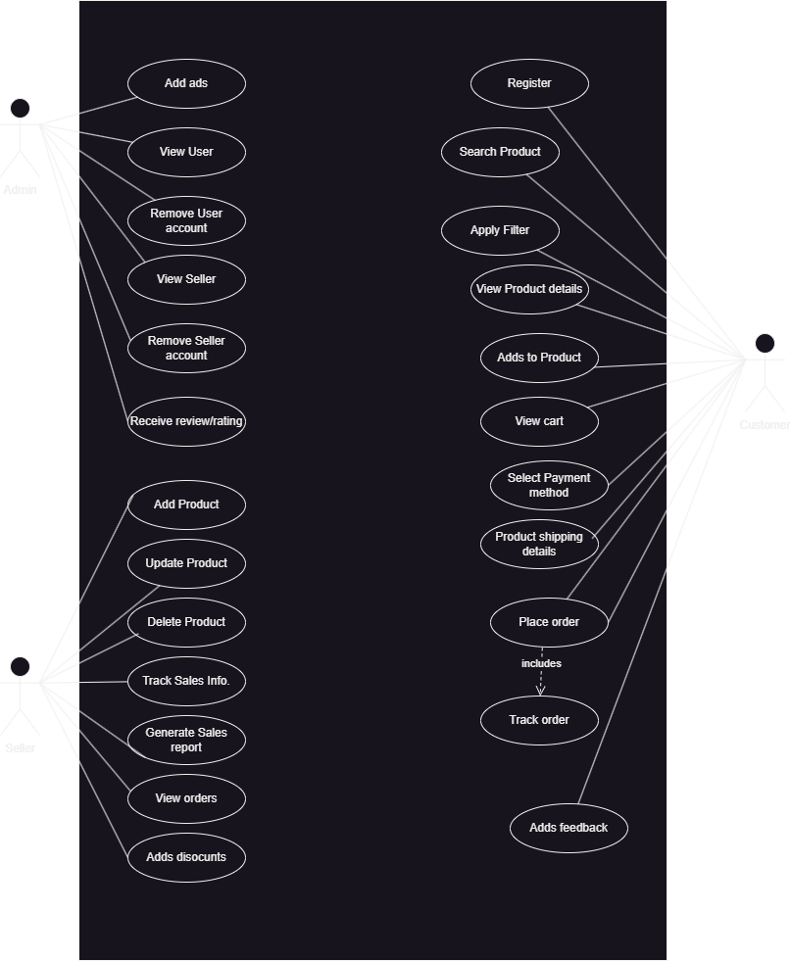

Figure ‑ Use case diagram for library management system

## Activity diagram and Swimlane diagram

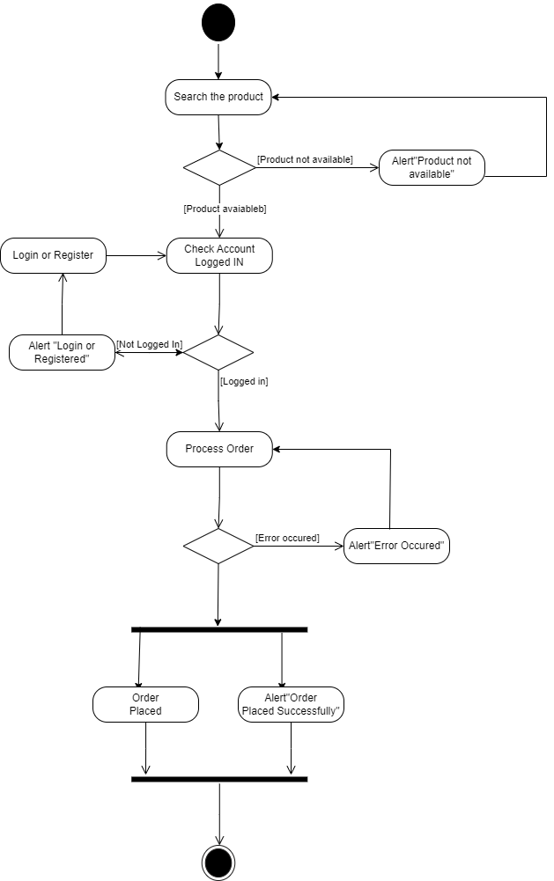

Figure ‑ Activity diagram for Product Ordering

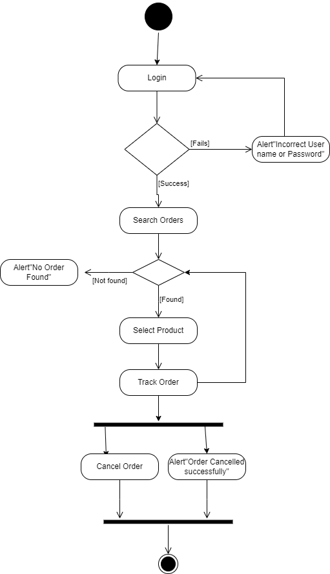

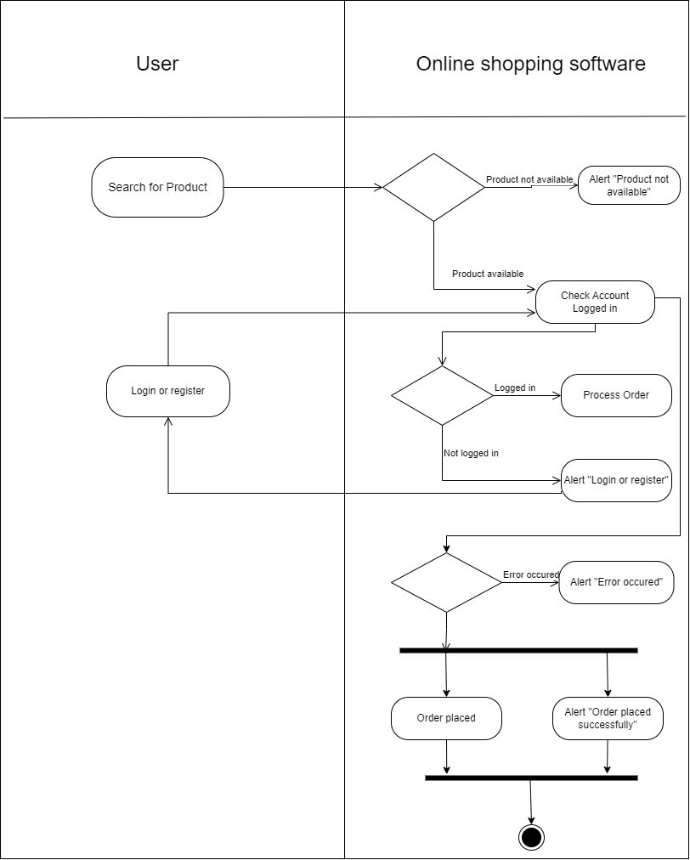

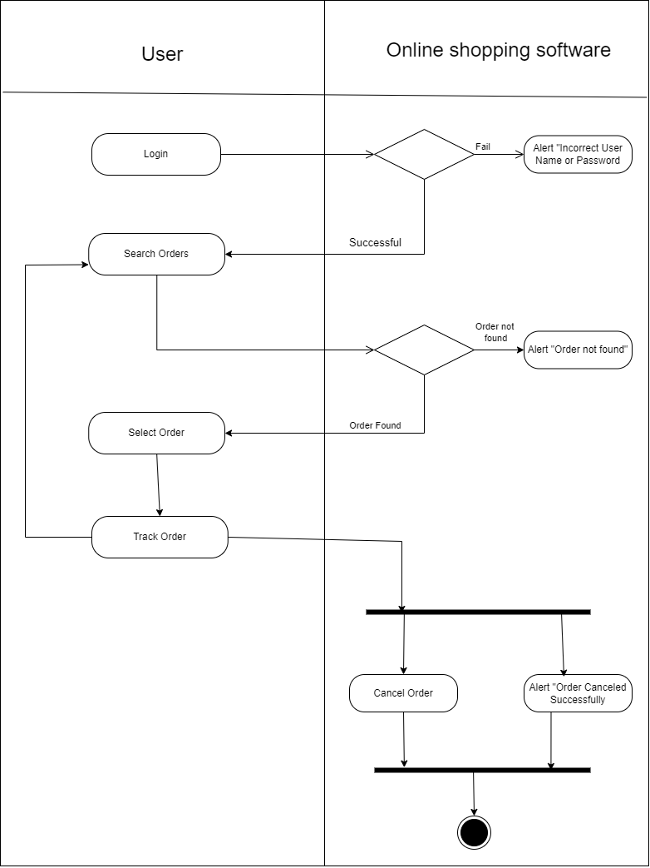

Figure ‑ Swimlane diagram for Book Issue

## Sequence diagram

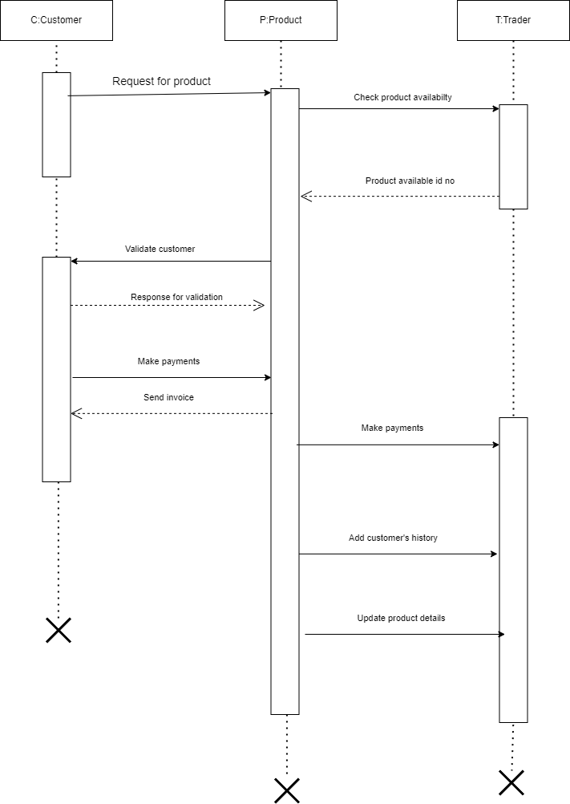

Figure ‑ Sequence diagram for Book Issue

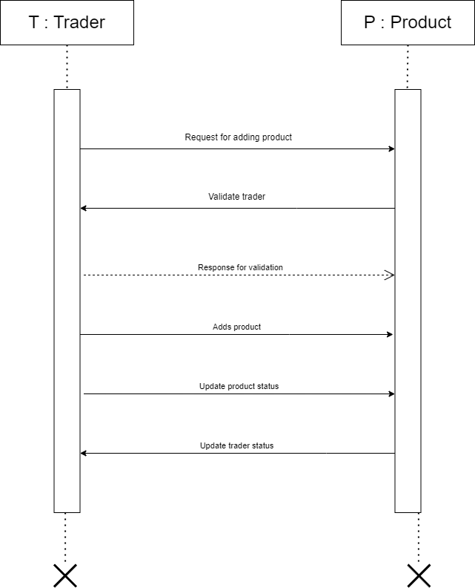

## State diagram

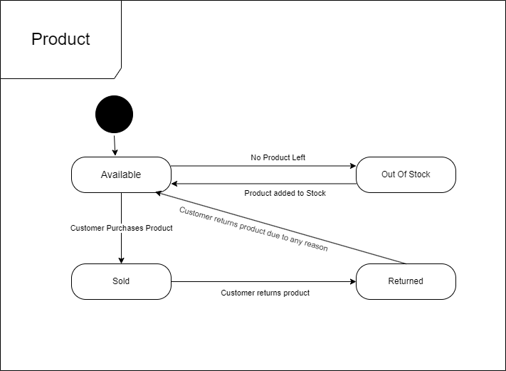

Figure ‑ State diagram of Product

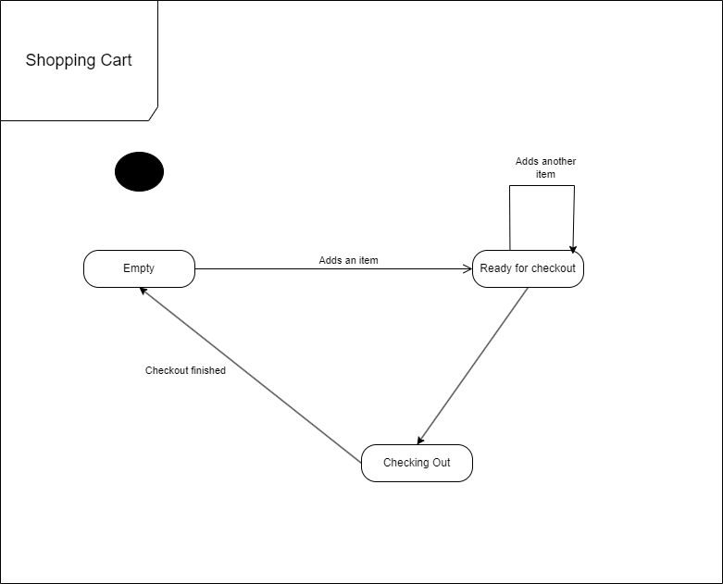

Figure ‑ State diagram for Shopping Cart

## Class diagram

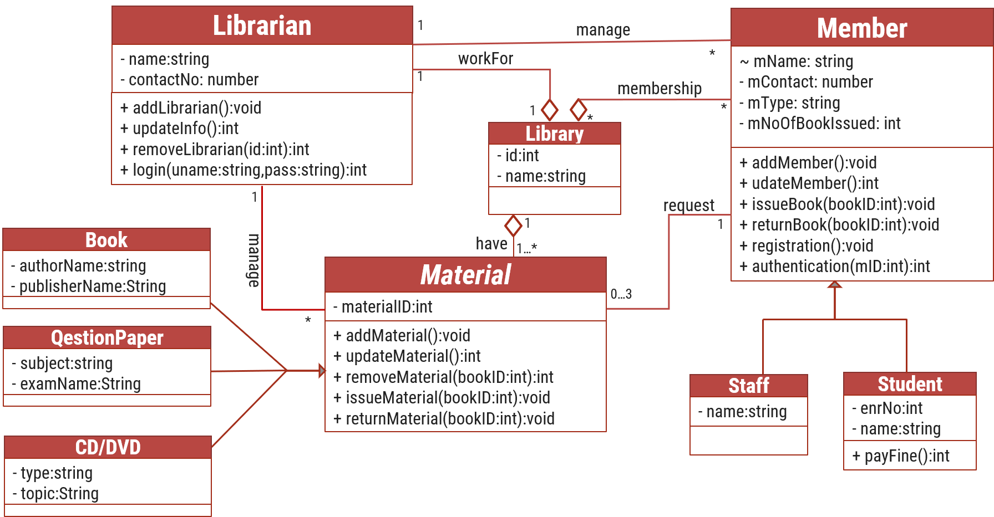

Figure ‑ Class diagram for Library management system

## Data flow diagram

### Context diagram (level-0)

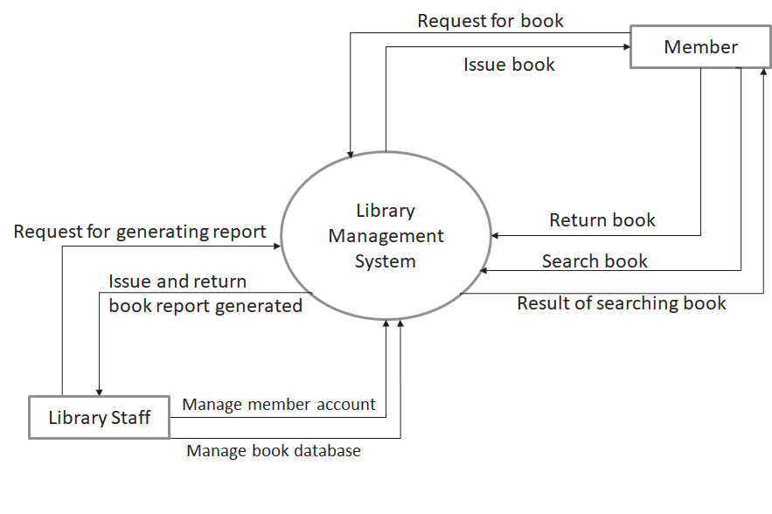

Figure ‑ Context diagram for Library management system

### DFD Level-1

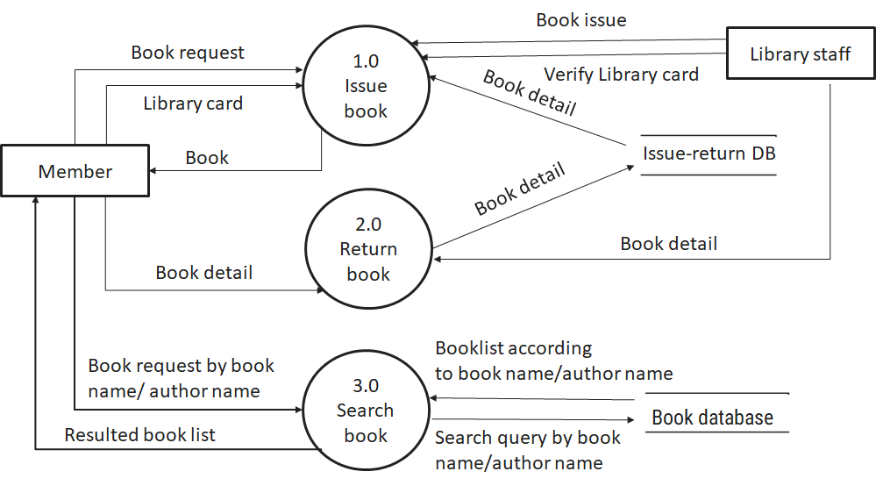

Figure ‑ DFD level-1 for Library management system

### DFD Level-2

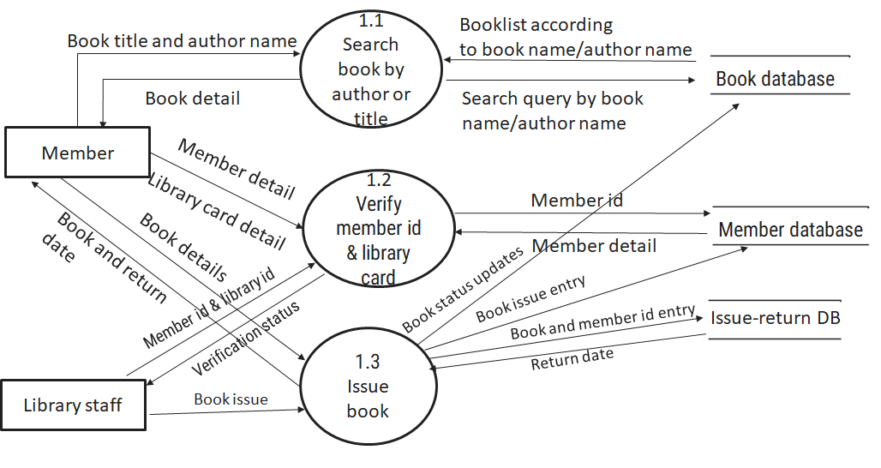

Figure ‑ DFD level-2 for Issue book

# External interface requirement (Screens)

## Screen-1: Seller Product Promotion Form

Figure ‑ Screen-1: Seller Product Promotion

**Purpose:** This form will provide sellers an opportunity to promote their products by paying a certain amount by advertising their products. Following options are needed to achieve the same.

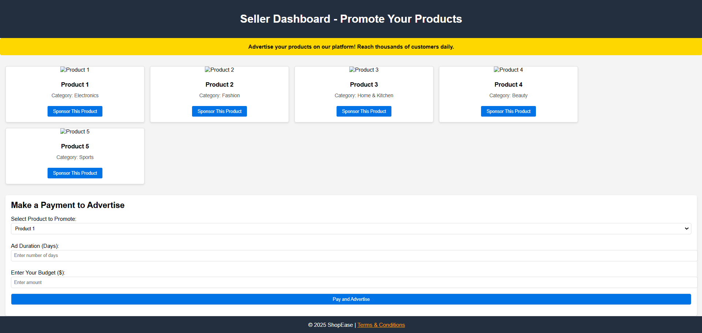

Table ‑ Screen element of Seller Product Promotion

|  |  |  |  |  |  |
| --- | --- | --- | --- | --- | --- |
| Sr. | Screen Element | Input Type | O/M | 1/N | Description |
| 1 | Sponsor this Product | Button | ------ | ----- | Sponsor this product button enables seller an option to sponsor products of their choice. |
| 2 | Select Product to promote | Dropdown | O | N | This dropdown enabled seller to choose from products selected above and proceed with payment. |
| 3 | Ad Duration | Textbox | M | 1 | Enter number of days to show the ads of that particular product. |
| 4 | Enter Budget | Textbox | M | 1 | Enter Budget is a textbox where seller can specify their budget for payment for advertising their product. |
| 5 | Pay and advertise | Button | ------ | ------ | Pay and register is a button where seller can pay for their product advertisement and advertise their product. |

## Screen-2: Seller Dashboard

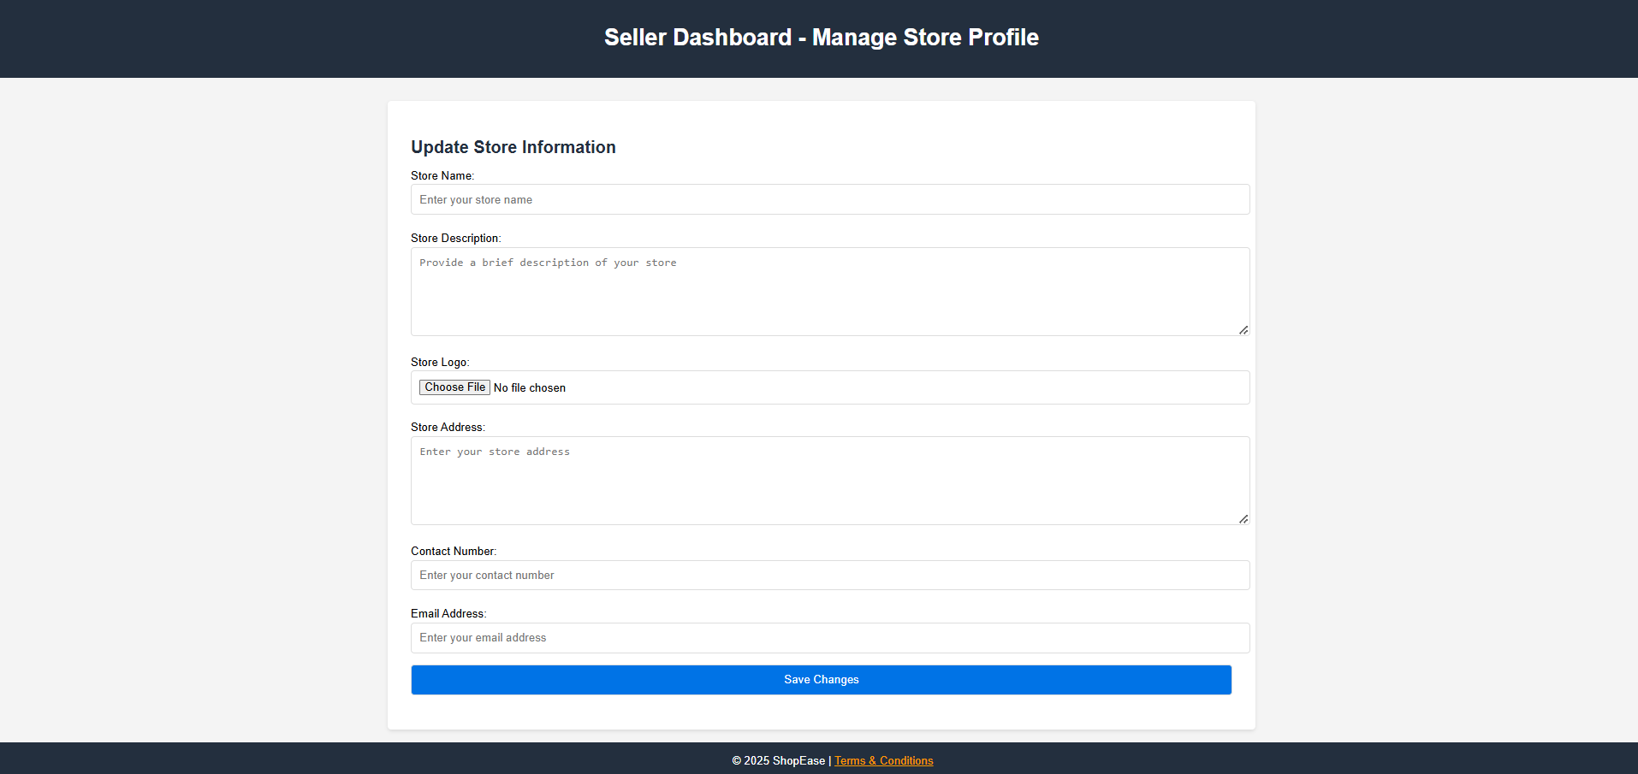

Figure ‑ Screen-2: Seller Dashboard

**Purpose:** This form will be used by sellers. Here they can manage their store profile and add changes if any, in their store profile.

Table ‑ Screen element of Seller Dashboard

|  |  |  |  |  |  |
| --- | --- | --- | --- | --- | --- |
| Sr. | Screen Element | Input Type | O/M | 1/N | Description |
| 1 | Store Name | Textbox | M | 1 | Store Name is a field where Seller mentions their Store Name. |
| 2 | Store Description | TextBox | M | 1 | Store Description is a field where seller describes what their store is about and what is provided by the store. |
| 3 | Store Logo | File | O | 1 | Here seller provides with their store logo if any. |
| 4 | Store Address | Textbox | M | 1 | Here seller mention their address of store or manufacturing place if any. |
| 5 | Contact Number | TextBox | M | N | Here store’s contact number is provided by seller. |
| 6 | Email Adress | TextBox | M | 1 | Here email address is provided of the store owner. |
| 7 | Save Changes | Button | ----- | ------ | This button when clicked saves the store’s portfolio in website’s database. |

## Screen-3: Customer Support

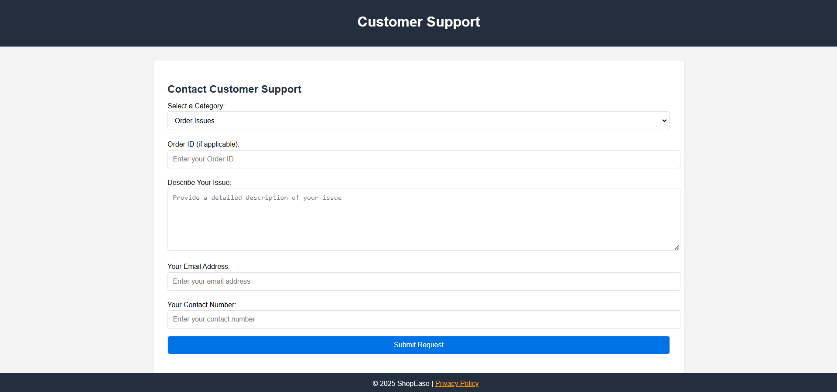

Figure ‑ Screen-3: Customer Support

**Purpose:** This module will allow customers to contact with the administrative team and getting help for any issue facing related to the same. Here they can provide information related to issue they are facing.

Table ‑ Screen element of Add borrower book

|  |  |  |  |  |  |
| --- | --- | --- | --- | --- | --- |
| Sr. | Screen Element | Input Type | O/M | 1/N | Description |
| 1 | Select a Category | Dropdown | M | 1 | Customer selects a category based on what issue they are facing. |
| 2 | Order ID | Textbox | M | 1 | Order ID must be a code of Order related to which Customer is facing the issue. |
| 3 | Describe your issue | Textbox | M | 1 | Here Customers describes about the issue they are facing. |
| 4 | Email Address | Textbox | M | 1 | Customers provides their email address which is linked to their account for their identity. |
| 5 | Contact Number | Textbox | M | N | Customers provides their contact number linked to their account for their identity. |
| 6 | Submit Request | Button | ----- | ------ | Submit Request button is a button to store the issue to their database and proceed the complaint further. |

## Screen-4: Return a Product Request Screen

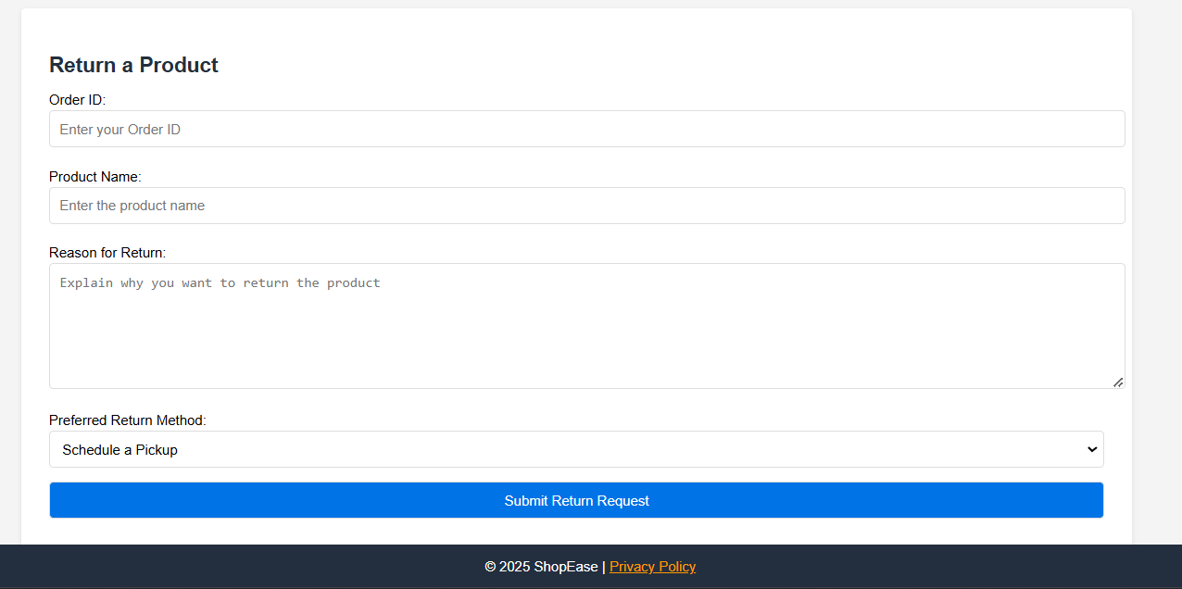

Figure ‑4 Screen-4: product request screen

**Purpose:** This module allows customer a feature to return the product. Here they can provide details of the product they are willing to return alongwith the details of the issue they are facing with it.

Table ‑3 Screen element of Product Request Screen

|  |  |  |  |  |  |
| --- | --- | --- | --- | --- | --- |
| Sr. | Screen Element | Input Type | O/M | 1/N | Description |
| 1 | Order ID | Textbox | M | 1 | Order ID is a code of the order which customer is willing to return. |
| 2 | Product Name | Textbox | M | 1 | Product Name consist the name of the product customer is willing to return. |
| 3 | Reason for return | Textbox | M | 1 | Here Customers describes about the issue they are facing with the product and why are they willing to return it. |
| 4 | Preferred return  method | DropDown | O | 1 | Customers chooses the method of the way they are willing to return their product. |
| 5 | Submit Return Request | Button | ----- | ----- | Submit Return Request button is a button to store the issue to their database and proceed their return request further. |

## Screen-5: Platform Customization

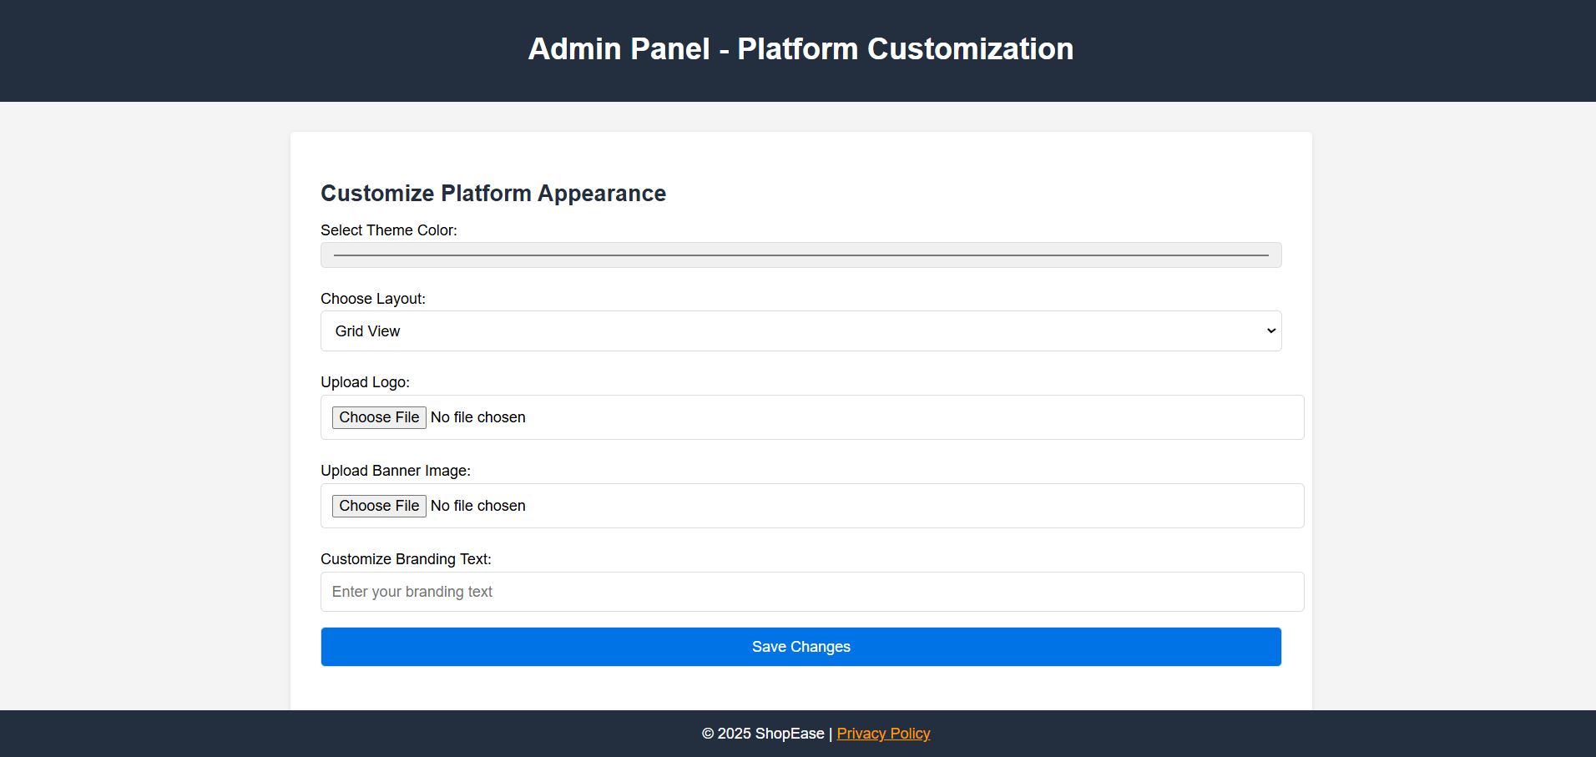

Figure ‑5 Screen-5: Platform Customization

**Purpose:** This module allows admin to customize the look to the applications with options to change the theme,logo and brand text and save the changes applied.

Table ‑5 Screen element of Platform Customization

|  |  |  |  |  |  |
| --- | --- | --- | --- | --- | --- |
| Sr. | Screen Element | Input Type | O/M | 1/N | Description |
| 1 | Select Theme Color | Color | M | 1 | Admin chooses a color from color pallete to apply as a theme to the application. |
| 2 | Choose Layout | Dropdown | O | 1 | Admin chooses the layout type for products as of how they will appear to the Users. |
| 3 | Upload Logo | File | M | 1 | Admin can select a logo for the application and is able to change it. |
| 4 | Upload Banner Image | File | M | 1 | Admin can select a banner for the application and is able to change it. |
| 5 | Customize Branding Text | Textbox | M | 1 | Admin is able to change or add a branding text to show in their application for branding of the application. |
| 6 | Save Changes | Button | ---- | ---- | Save Changes is a button to save the platform customization changes made by the admin. |

# Database design

## List of Tables

* Product
* Customer
* Order
* Seller
* Cart

Table ‑1 Table: Product

|  |  |  |  |  |
| --- | --- | --- | --- | --- |
| Column | Data Type | Null | Keys & Constrains | Default Value & Description |
| BookID | int | NN | PK (Auto Increment) |  |
| BookName | varchar(100) | NN |  |  |
| ISBN | varchar(100) | AN |  |  |
| Publication_year | int | AN |  |  |
| Language | varchar(50) | AN |  |  |

Table ‑2 Table: Customer

|  |  |  |  |  |
| --- | --- | --- | --- | --- |
| Column | Data Type | Null | Keys & Constrains | Default Value & Description |
| CustomerID | int | NN | PK (Auto Increment) | -- |
| Name | String | NN | -- | -- |
| UserName | varchar(100) | NN | -- | -- |
| PhoneNumber | number(10,0) | NN | -- | -- |
| Email | varchar(50) | NN | -- | -- |
| Address | Varchar(100) | NN | -- | -- |

Table ‑3 Table: Order

|  |  |  |  |  |
| --- | --- | --- | --- | --- |
| Column | Data Type | Null | Keys & Constrains | Default Value & Description |
| OrderID | int | NN | PK (Auto Increment) |  |
| CustomerID | int | NN | FK | Reference of Customer Table |
| ProductID | int | NN | FK | Reference of Product Table |
| Amount | int | NN | -- | -- |
| ProductDescription | Varchar(100) | NN | -- | -- |
| OrderBy | DateTime | NN | -- | -- |
| DeleveryBy | DateTime | NN | -- | -- |

Table -4 Table: Vendor

|  |  |  |  |  |
| --- | --- | --- | --- | --- |
| Column | Data Type | Null | Keys & Constrains | Default Value & Description |
| Vendor_ID | int | NN | PK (Auto Increment) | -- |
| Vendor_Name | String | NN | -- | -- |
| Vendor_UserName | varchar(100) | NN | -- | -- |
| Vendor_Product | String | NN | -- | -- |
| Vendor_Address | varchar(100) | NN | -- | -- |
| Vendor_PhoneNumber | number(10,0) | NN | -- | -- |

Table ‑5 Table: Cart

|  |  |  |  |  |
| --- | --- | --- | --- | --- |
| Column | Data Type | Null | Keys & Constrains | Default Value & Description |
| CustomerID | int | NN | FK | Reference of Customer Table |
| ProductID | int | NN | FK | Reference of Product Table |
| Total_item | int | NN | -- | -- |
| Total_Amount | int | NN | -- | -- |
| Item_Des. | Varchar(100) | AN | -- | -- |

# Stories and Scenario

## Story-1: Add New Product in Product Catalogue

|  |  |  |
| --- | --- | --- |
| *Story # S1* | : | As a Seller,  I want to add a new product in product catalogue  So that everyone can easily find and purchase it. |
| Priority | **:** | High |
| Estimate | **:** | XL |
| Reason | **:** | The addition of a new product to the product catalogue is crucial for ensuring that the product's collection is up-to-date and accessible to everyone. |

### Scenario# S1.1

|  |  |  |
| --- | --- | --- |
| *Scenario# S1.1* | : | Adding a New Product with Valid and Complete Information |
| Prerequisite | **:** | Seller is logged in to the Online Shopping management system. |
| Acceptance Criteria | **:** | **Given:**  The Seller is navigated to the product catalog management page. Valid product information, including name,description,price and other relevant details is added.  **When:**  The seller selects the "Add New Product" option  And The seller enters valid and complete product details  The seller clicks the "Save" button to add the product to the catalog.  **Then t**he system successfully adds the product to the catalog and the seller receives a confirmation message with the product's identification number. |

### Scenario# S1.2

|  |  |  |
| --- | --- | --- |
| *Scenario# S1.2* | : | Adding a New Book with Incomplete Information. |
| Prerequisite | **:** | The seller is logged into the online shopping management system. |
| Acceptance Criteria | **:** | **Given:** The seller is on the product catalogue management page**.**  **When:** The seller selects the "Add New Product" option and the seller enters an incomplete or incorrect product details and seller clicks the "Save" button to add the product to the catalogue.  **Then t**he system displays error messages for the incorrect or missing information and the product is not added to the catalogue. |

## Story-2: Search Product

|  |  |  |
| --- | --- | --- |
| *Story # S2* | : | As a Customer,  I want to search for product  So that I can quickly find products that match my interests. |
| Priority | **:** | High |
| Estimate | **:** | L |
| Reason | **:** | Implementing a search functionality is essential for enhancing the user experience, as it allows customers to efficiently discover and access the store's products. |

### Scenario# S2.1

|  |  |  |
| --- | --- | --- |
| *Scenario# S2.1* | : | Searching a product by its name that exists. |
| Prerequisite | **:** | The customer is logged into online shopping system |
| Acceptance Criteria | **:** | **Given:**  The Customer is in Home Page or Product Search Page  **When:**  The customer enters the product name in search bar (e.g.: ps5) which exists in the store.  The customer clicks the search button.  **Then t**he system displays list of products matching the search term including relevant details like price and ratings. |

### Scenario# S2.2

|  |  |  |
| --- | --- | --- |
| *Scenario# S2.2* | : | Searching a product by its name that does not exist |
| Prerequisite | **:** | The customer is logged into online shopping system |
| Acceptance Criteria | **:** | **Given:**  The Customer is in Home Page or Product Search Page  **When:**  The customer enters the product name in search bar that does not exist.  The customer clicks the search button.  **Then t**he system displays message as ‘No Such Product Exists’. |

## Story-3: Return Product

|  |  |  |
| --- | --- | --- |
| *Story # S3* | : | As Customer,  I want to return a product that I purchased  So that I can get refund of the product. |
| Priority | **:** | High |
| Estimate | **:** | L |
| Reason | **:** | Product return functionality is a convenience feature for customer, allowing them to return a product within a certain period of time incase of any malfunctions. |

### Scenario# S3.1

|  |  |  |
| --- | --- | --- |
| *Scenario# S3.1* | : | Return a Product within given time limit |
| Prerequisite | **:** | The customer is logged into online shopping system and have purchased a product from the online store. |
| Acceptance Criteria | **:** | **Given:**  The Customer is in Product Information Page or Your Orders page.  **When:**  The customer clicks on Return Product option and fill all the relevant details like reason for returning and returns it within their time limit.  **Then t**he system starts the process of collecting the order from customer and customer receives confirmation message on their return request. |

### Scenario# S3.2

|  |  |  |
| --- | --- | --- |
| *Scenario# S3.1* | : | Return a Product after given time limit |
| Prerequisite | **:** | The customer is logged into online shopping system and have purchased a product from the online store. |
| Acceptance Criteria | **:** | **Given:**  The Customer is in Product Information Page or Your Orders page.  **When:**  The customer clicks on Return Product option and fill all the relevant details like reason for returning and returns it after their given time limit.  **Then t**he system displays error message saying ‘Return Request Time Out’. |

## Story-4: Renew book

|  |  |  |
| --- | --- | --- |
| *Story # S3* | : | As Librarian,  I want to renew a book that I have borrowed  So that I can extend my borrowing period if needed. |
| Priority | **:** | Medium |
| Estimate | **:** | M |
| Reason | **:** | Book renewal functionality is a convenience feature for librarian, allowing them to keep a book for an extended period if no one else has requested it. |

## Story-5: Generate a report on book usage and availability

|  |  |  |
| --- | --- | --- |
| *Story # S3* | : | As Librarian,  I want to generate reports on library usage and book availability  So that I can make informed decisions about library’s books. |
| Priority | **:** | Medium |
| Estimate | **:** | L |
| Reason | **:** | Reporting functionality helps librarians track the usage of library resources and make data-driven decisions to improve services and collections. |

# Test cases

|  |  |  |  |
| --- | --- | --- | --- |
| Project Name: | EMI Calculator | Test Designed by: | P. U. Jadeja |
| Module Name: | **Login** | **Test Designed date:** | 01-10-2023 |
| Release Version: | **1.0** | **Test Executed by:** | **R. B. Gondaliya** |
|  |  | **Test Execution date:** | 15-01-2023 |

|  |  |  |  |  |
| --- | --- | --- | --- | --- |
| Pre-condition: Web application should be accessible | | | | |
| Test Case ID | **Test Title** | **Test Type** | **Description** | **Test Case ID** |
| TC_001 | Login to web application with valid credential | Functional | Login to Library management system web application through valid credential | TC_001 |
| TC_002 | Login to web application with invalid credential | Functional | Login to Library management system web application through invalid credential | TC_002 |
| TC_003 | Varify login page elements | GUI | varify that all elements are availabe on login page | TC_003 |

|  |  |
| --- | --- |
| **Test Case Title** | Login to web application with valid credential |
| **Test Type** | Functional |
| **Test Priority** | High |
| **Pre-condition** | Web application should be accessible |

|  |  |  |  |  |  |  |  |
| --- | --- | --- | --- | --- | --- | --- | --- |
| **Test Step** | **Test Case Description** | **Expected Result** | **Actual Result** | **Status** | **Comment** | **Data** | **BUG ID** |
| 1 | Access Web application URL | The site launched properly | Site launched successfully | Pass |  | <https://accounts.google.com/ServiceLogin> |  |
| 2 | Enter valid Username in username field | Username field should be editable and accept the Username | Username input accepted | Pass |  | Username:  Rbgondaliya@gmail.com |  |
| 3 | Enter valid Password in Password field | Password field should be editable and accept the password and display as star or dot | Password input displayed in dot and accepted | pass |  | Password: rbgondaliya |  |
| 4 | Enter valid captcha code in captch field | Captch field should editable and accept captcha and captcha is case sensitive | Captcha input accepted | Pass | Step required when human action validation perform | get captcha from image which is near by captcha field |  |
| 5 | Click on login button | User should login into site and navigated to dashboard | User navigated to dashboard and username should br display in top of the right side. | pass |  |  |  |

|  |  |
| --- | --- |
| **Test Case Title** | Login to web application with invalid credential |
| **Test Type** | Functional |
| **Test Priority** | Medium |
| **Pre-condition** | Web application should be accessible |

|  |  |  |  |  |  |  |  |
| --- | --- | --- | --- | --- | --- | --- | --- |
| **Test Step** | **Test Case Description** | **Expected Result** | **Actual Result** | **Status** | **Comment** | **Data** | **Bug ID** |
| 1 | Verify that User is not able to Login with invalid Username and invalid Password | Should be display an error message enter wrong username or password | Display an error of wrong username and password | Pass |  |  |  |
| 2 | Verify that User is not able to Login with Valid Username and invalid Password | Should be display an error message enter wrong password | Display an error of wrong password | Pass |  |  |  |
| 3 | Verify that User is not able to Login with invalid Username and Valid Password | Should be display an error message User not found | Display an error Username not found | Pass |  |  |  |
| 4 | Verify that User is not able to Login with blank Username or Password | Set required field validation message for Username and Password | Display an error of wrong username and password | Fail | Not performa a validation function fix it |  | Bug_002 |

|  |  |
| --- | --- |
| **Test Case Title** | Varify login page elements |
| **Test Type** | GUI |
| **Test Priority** | Medium |
| **Pre-condition** | Web application should be accessible |

|  |  |  |  |  |  |  |  |
| --- | --- | --- | --- | --- | --- | --- | --- |
| **Test Step** | **Test Case Description** | **Expected Result** | **Actual Result** | **Status** | **Comment** | **Data** | **Bug ID** |
| 1 | Launch application with the given url | The site launched properly | Site launched successfully | Pass |  | <https://accounts.google.com/ServiceLogin> |  |
| 2 | Verify that the login screen contains elements such as Username, Password, Sign in button, Remember password check box, Forgot password link, and Create an account link. | All listed control displayed properly on the page | Login page loaded successfully | Pass |  |  |  |
| 3 | Verify that cursor is focused on “Username” text box on the page load | Cursor is focused in Username textbox | Cursor focus in Username textbox | Pass |  |  |  |
| 4 | Verify that tab functionality is working properly or not | When tab pressed cursor move in next control | Cursor moving in next control | Pass |  |  |  |
| 5 | Verify that all the fields such as Username, Password has a valid placeholder | All text fields have proper placeholder | All text fields have proper placeholder | Pass |  |  |  |
| 6 | Verify that the labels float upward when the text field is in focus or filled (In case of floating label) | When field is focused or filled, label display on top of the filled | When field is focus or filled, label display on top of the filled | Pass | step required when fields with floating label |  |  |
| 7 | verify that forgot password link working properly | when click on forgot password load forgot passworg page | forgot password link not working | Fail |  |  |  |

# References

* http://www.w3schools.com/html/html_intro.asp
* https://www.w3schools.com/php/default.asp
* https://www.javatpoint.com/uml